Final Exam
World History I

Choose 10 questions below. Answer each question in two or three complete sentences. Be sure to number your questions.

- How did physical geography determine the lives of early humans?
- How did the beginning of agriculture and the domestication of animals promote the rise of settled communities?
- Why did ancient civilizations develop in river valleys?
- What were the social, political, and economic characteristics of early civilizations?
- Why was the caste system central to Indian culture?
- How did Buddhism spread?
- How did the mountains, seas, islands, harbors, peninsulas, and straits of the Aegean Basin shape Greek economic, social, and political development and patterns of trade and colonization?
- What were some important contributions of Greek culture to Western civilization?
- How was geographic location important to economic, social, and political development of ancient Rome?
- Why was Rome able to conquer Carthage and then go on to extend its influence across the entire Mediterranean basin and much of Western Europe?
- Why was Constantinople established as the capital of the Eastern Roman Empire?
- What was the influence of Justinian’s codification of Roman law on the Byzantine Empire and later legal codes?
- What are the beliefs, traditions, and customs of Islam?
- What were some contributions of Islamic civilization?
- How did a feudal society develop in Europe during the Middle Ages?
- How did the Black Death alter economic and social institutions in much of Asia and then in Europe?
- How did Charlemagne revive the idea of the Roman Empire?
- Where were the major trade routes in the Eastern Hemisphere from 1000 to 1500 a.d.?
- What were the characteristics of civilizations in sub-Saharan Africa during the medieval period?
- What were the characteristics of Mayan, Aztec, and Incan civilizations?
- What were key events and effects of the Crusades?
- How did European scholars begin to interpret and value ancient learning?
- How did the Crusades stimulate trade between Europe and the Muslim Empire?
- How did northern Italian cities benefit from their geographic location?
- How did the arts and literature of the Renaissance differ from those of the Middle Ages?

Multiple Choice Section

The Prehistoric World
- Neolithic societies paved the way for civilization by doing which of the following?
  - Converting early farmers into hunter-gatherers
  - Fostering settled and secure communities
  - Depicting life in cave paintings
  - Mastering fire and traveling over wide areas

- Which of the following does NOT describe people during the Paleolithic Era?
  - Hunter-gatherer
  - Nomadic
  - Using simple tools
  - Creating advanced tools

- The life of people living in hunter-gatherer societies were most shaped by
  - The stars
  - The shapes of their bodies
  - Their physical environments
  - The days of the week
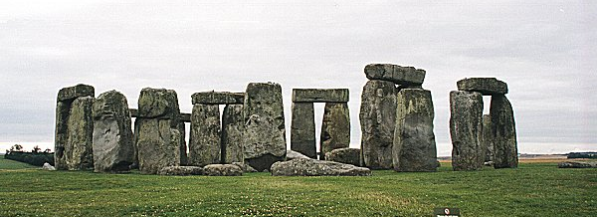
- The photo above depicts what Neolithic artifact?
  - Stone Mountain
  - Stonehenge
  - Ms. Day’s childhood home
  - The Great Stone Artifact

- Which term indicates the Middle Stone Age?
  - Paleolithic
  - Bronze Age
  - Mesolithic
  - Neolithic

- Scientists who investigate prehistoric people by unearthing and interpreting objects are called
  - Anthropologists
  - Paleontologists
  - Archeologists
  - Meteorologists

- What was the Neolithic Revolution?
  - The changing from hunting-gathering to farming.
  - A war for independence
  - The movement of people across the world
  - The change from settled communities to hunting-gathering clans
- The domestication of animals and the development of agriculture led to
  - The rise of settled communities
  - People becoming vegetarian
  - A decrease in the world’s population
  - Extinction of Homo Sapiens

- The period of time after people first appeared but before they developed writing is known as
  - Civilization
  - History
  - Prehistory
  - Paleolithic Era

Identify each of the following as either Paleolithic or Neolithic.
- Paleolithic
- Neolithic
- Old Stone Age
- Agriculture
- Domesticate Animals
- Nomads
- Villages

Early Civilizations
- Where did the fist cities emerge?
  - Along trade routes
  - In river valleys
  - Along the Mediterranean coast
  - In the Americas

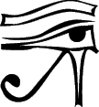
- When the early Egyptians used pictures like the one above to stand for objects, this was called:
  - Cuneiform
  - Alphabet
  - Clay Tablets
  - Hieroglyphics

- The ____________ is to the Hebrews as Hammurabi’s Code is to the ____________.
  - 10 Commandments, Babylonians
  - 10 Commandments, Sumerians
  - Bible, Babylonians
  - Rosetta Stone, Phoenicians

- The Phoenicians could be called “carriers of civilizations” because
  - They conquered the Fertile Crescent
  - They established the first library
  - They spread their culture through trade
  - They invented the wheel.

Use the map to identify the locations of early civilizations.
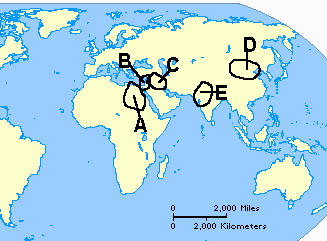
- Canaan
- Egypt
- Harappa
- Mesopotamia
- Shang

Use the map below to identify the rivers.
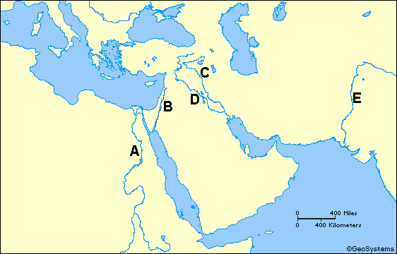
- Indus
- Jordan
- Nile
- Tigris

Match each of the following early civilizations with the appropriate river(s).
  - Huang He
  - Indus
  - Nile
  - Tigris
- The Egyptians
- The Harappans
- The Shang

- A study of the Indus, Nile, Huang He, and Tigris-Euphrates systems would be most useful in understanding the
  - Causes of decline of Mediterranean trade.
  - Role of geography in the development of early civilizations
  - Reasons why nomadic tribes dominated prehistory
  - Rise of Islam as a major cultural force in the Middle East.

Persia, India, and China
- Which two features were fundamental to the success of the Persian Empire?
  - Aggressive military policy with efficient transportation.
  - Ample mineral resources and large-scale craft production.
  - Centralized government with tolerance of diversity.
  - Forceful rulers in a time of prosperity.
- Which two groups performed the most similar functions?
  - Aryan nomads and Chinese silk merchants
  - Buddhist scholars and Gupta poets
  - Chinese emperors and Indian Shudras
  - Persian bureaucrats and Chinese Civil Servants

- Which statement best relates the origin of Buddhism to the evolution of Hinduism?
  - Buddhism and Hinduism evolved together from Vedic times.
  - Buddhism was a reaction to Hinduism’s emphasis on rituals.
  - Hinduism combined Aryan and Buddhist teachings
  - The Upanishads brought Hinduism in line with Buddhist thought.

- Which statement best describes the impact of Confucian teachings on Chinese government?
  - Confucius emphasized the happiness of those who are ruled.
  - Confucius supported the Chinese nobles in their struggle for power.
  - Respect for elders, politeness in society, and ancestor worship are ideas attributed to Confucius.
  - The Mandate of Heaven, attributed to Confucius, called for fair and just government.

- All of the following religions or philosophies are associated with classical China EXCEPT
  - Buddhism
  - Hinduism
  - Taoism
  - Confucianism

- What feature of Taoism (Daoism) is most contrary to the teachings of Confucius?
  - “Inaction,” letting nature takes its course.
  - Concern for proper behavior.
  - Emphasis on good manners and humility.
  - The balance of opposing forces.

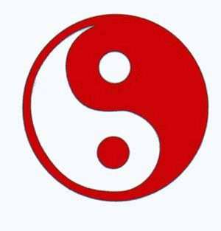
- The above symbol is most closely associated with which religion?
  - Daoism
  - Confucianism
  - Hinduism
  - Buddhism

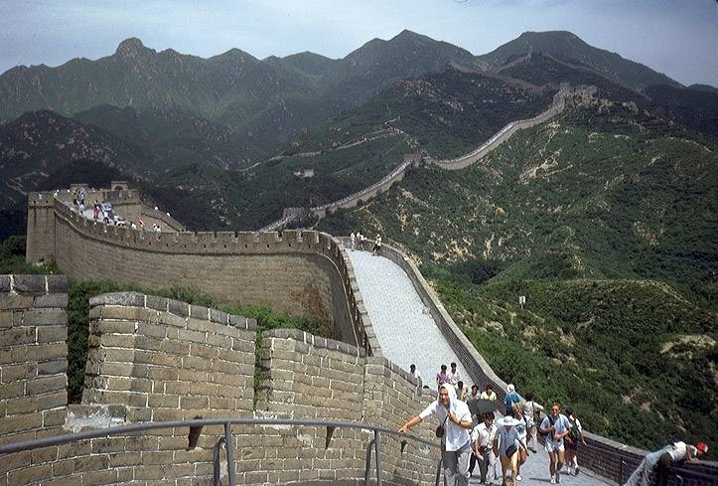
- Which best explains why the above structure was built?
  - Protect the Silk Road
  - Provide irrigation
  - To keep out invaders
  - Permit flood control.

- The Aryans are best described as
  - Hunter-gatherers
  - Warrior-herders
  - Merchants
  - Farmers

- Asoka adopted Buddhism after
  - The collapse of the Hindu caste system.
  - Witnessing the aftermath of a brutal battle.
  - Seven years of wandering
  - Witnessing scenes of shocking poverty outside his palace.

Use the map below to identify the early classical empires.
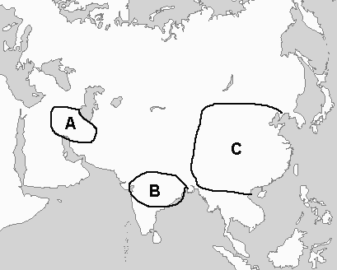
- Gupta
- Han
- Persia

- India’s Golden Age occurred under which ruler?
  - Nebudchadnezzar
  - Han
  - Chandragupta
  - Chandragupta I

- Zoroastrianism influenced which religions?
  - Judaism, Christianity, Confucianism
  - Islam, Christianity, Judaism
  - Islam, Hinduism, Buddhism
  - Confucianism, Daoism, Buddhism

Use the map below to identify the items that follow.
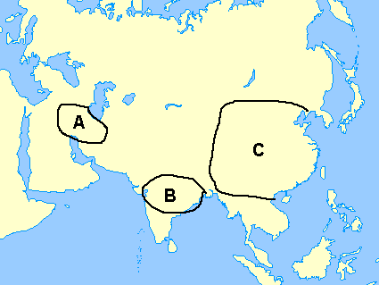
- Place where Buddhism started.
- Area where Darius I ruled.
- Land of Confucianism.
- Location of the Royal Road.

Ancient Greece
- The defeat of the Persians left the Greeks in control of the _____________ region.
  - Mediterranean
  - Atlantic
  - Anatolian
  - Aegean

Use the map below to answer the question that follows.
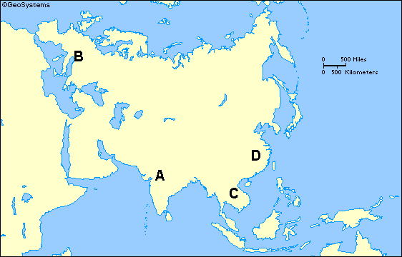
- What is the farthest easterly extent of Alexander the Great’s conquest?

- From childhood, Spartan boys were trained to be
  - Philosophers
  - Politicians
  - Soldiers
  - Artists

Use the photo below to answer the questions that follow.
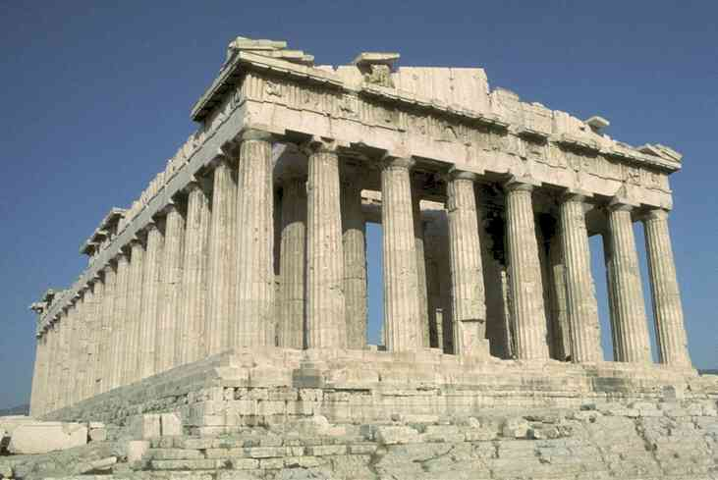
- The structure above was dedicated to which god/goddess?
  - Hera
  - Zeus
  - Apollo
  - Athena

- The Peloponnesian Wars were fought
  - Between Athens and Sparta for control of the region
  - Between Athens and Carthage for control of the Mediterranean
  - Between Athens and Rome for control of trade routes
  - Between Athens and the Macedonians for control of lands to the East

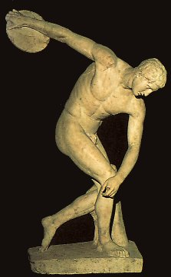
- This sculpture of an Olympian athlete is by
  - Herodotus
  - Hypocrites
  - Aristotle
  - Phidias

Ancient Rome
- The representatives of the plebeians were called
  - Consuls
  - Senators
  - Tribunes
  - Praetors

- During the Pax Romana, Romans did all of the following EXCEPT
  - Accept Islam as the official religion.
  - Build a series of aqueducts
  - Build the Coliseum
  - Trade with places as distant at Britain

- In 60BC, Caesar, Pompey, and Crassus formed a governing group called
  - A triumvirate
  - A republic
  - A consulate
  - A legion

- In 451 BC, the patricians finally
  - Allowed intermarriage between plebeians and Minoans
  - Eliminated the Assembly of Centuries
  - Eliminated the Assembly of Tribes
  - Put Roman law into writing

- The first emperor of Rome took the title
  - Proconsul
  - Claudius
  - Odoacer
  - Augustus

Use the photo below to answer the two questions that follow.
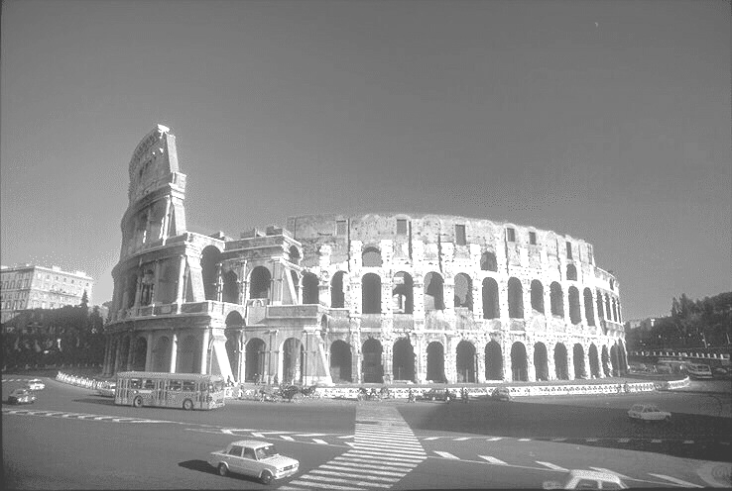
- The above structure was used for
  - Carrying water from the Mediterraneans Sea to the local villages
  - Praying to the Gods of Mount Olympus
  - Holding mock battles and contests
  - Crowning the Emperor Alexander

- The decline of the Roman Republic followed a century of civil wars fought over a question of
  - Which gods to worship
  - Who should hold power
  - Which language to speak
  - How to keep out invaders

- Which of the following is NOT related to the fall of Rome?
  - Germanic invasions
  - Corrupt officials
  - The assassination of Julius Caesar
  - Heavy taxes

- A problem that led to the end of the Roman Republic was that there was no law
  - Stating who could vote
  - That established a line of succession for the emperor
  - About regulating the currency
  - Giving patricians the right to vote

Use the map below to answer the question that follows.
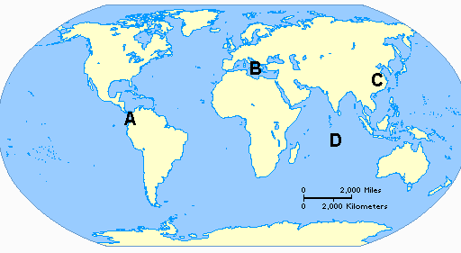
- At which letter is the Roman Empire located?

- Which large body of water was central to the Roman Empire?
  - Mediterranean Sea
  - East China Sea
  - Baltic Sea
  - Sea of Alexander

- The principle of being “innocent until proven guilty” is found in
  - The Torah
  - The Cyrillic Code
  - The Twelve Tablets
  - The Koran

- Homer’s Iliad can be compared to Virgil’s
  - Aeneid
  - Journey of the Roman Soldier
  - Orapax
  - Sinthetico

Byzantine Empire
- The Byzantine Empire reached its height under which emperor?
  - Justinian
  - Diocletian
  - Constantine
  - Caesar

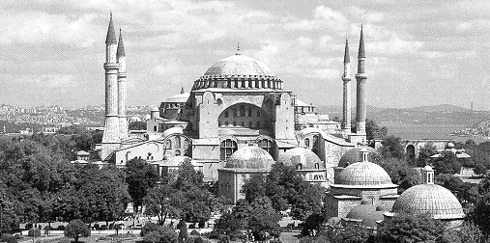
- The picture above depicts which structure?
  - Church of the Holy Mosaics
  - Hagia Sophia
  - Hagia Constantine
  - Holy Sophia

- The Byzantine Empire contributed to art and architecture in which of the following ways:
  - The Arch
  - The Flying Buttress
  - The Mosaic
  - Stained Glass

- What impact did the emperor Justinian have on present-day Western culture?
  - Sports
  - Trade
  - Literature
  - Legal codes

GO ON TO THE NEXT PAGE

Use the timeline below to answer the questions that follow.

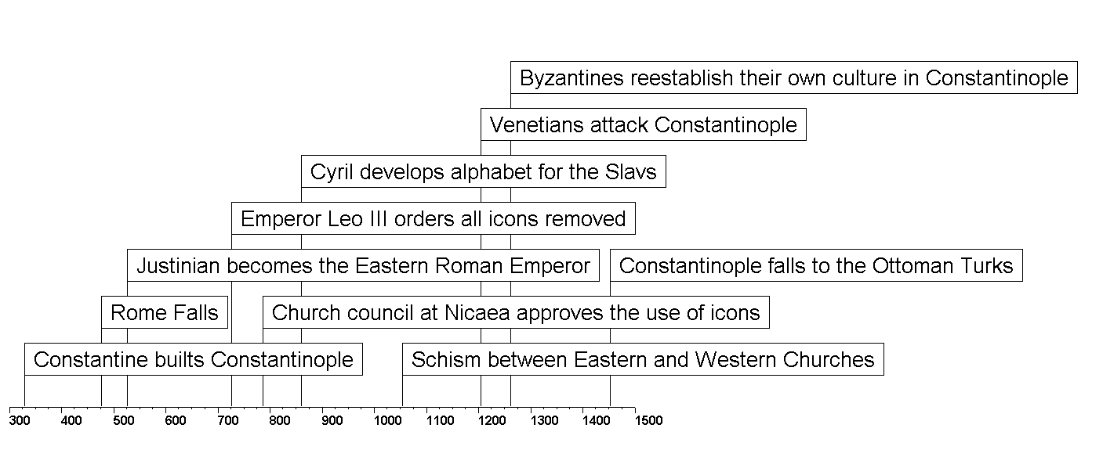

- How many years passed between the rise and fall of Constantinople?
  - 100
  - 1123
  - 515
  - 565

- What happened in 1453?
  - Rome fell.
  - The Christians captured Jerusalem.
  - Constantinople was renamed Istanbul.
  - Urban urged the Muslims to fight the Jews.

GO ON TO THE NEXT PAGE

Use the map below to identify the cities that follow.
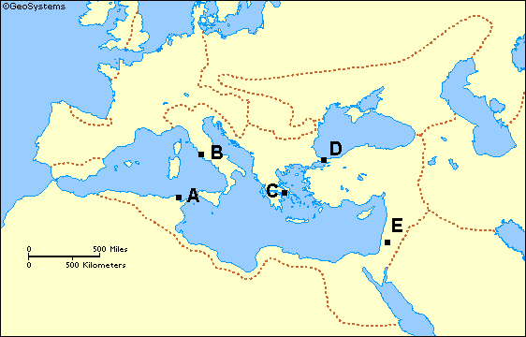
- Carthage
- Constantinople
- Jerusalem

- Supporters of Leo III’s ban on religious images were known as
  - Laity
  - Patriarchs
  - Regents
  - Iconoclasts

- Constantine chose the city of Byzantium for his new capital because it was
  - A magnificent city with a wealth of monumental architecture
  - An easily defended port city
  - The spiritual home of Justinian’s family
  - The center of the Roman military command.

Islamic Civilization
- A significant contribution of Islamic culture to Western Civilization is
  - The introduction of important land reforms.
  - The establishment of the principle of separation of Church and State
  - Advancements in mathematics and geography
  - Placing women in a superior position in society.

- The division between the Sunni and Shi’a took place over
  - Who would become the next caliph
  - Who would built Hagia Sophia
  - Who gets to read the Torah during the services
  - What time to pray everyday.

- Which of the following cities is the most holy city to Islam?
  - Mecca
  - Medina
  - Constantinople
  - Jerusalem

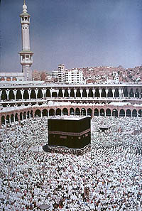

- Referring to the photo above, at least once in his or her life, if they are physically and financially able to do so, every Muslim must
  - Fast during Ramadan
  - Go to University
  - Complete the Hajj to Mecca
  - Pray during the Festival of Prayer

- Which of the following is NOT a scientific contribution from the Islamic rule?
  - Arabic numerals
  - Algebra
  - Expansion of geographic knowledge
  - Humanistic art

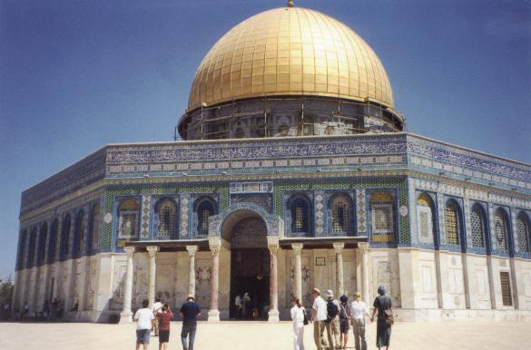
- What would take place in the above structure?
  - The Grand Bazaar
  - Prayer
  - The Yearly Alms
  - Jihad

- Which factor contributed MOST to the successful spread of Islamic civilization
  - Muslim respect for science literature
  - Arab skill in using the stars to find their way in the desert
  - The weakness of the western Roman empire
  - Muslim tolerance of local customs and practices.

- Muslim expansion in Europe was stopped at
  - Rome
  - Constantinople
  - Rota
  - Tours

Early Medieval Era
- What group of people was responsible for carrying Christianity to the Germanic tribes?
  - The serfs
  - The knights
  - The missionaries
  - The guild

- Charlemagne was given what honor by the Pope?
  - Being crowned Holy Roman Emperor
  - Being allowed to view the Holy Torah
  - Being brought into the Inquisition
  - Being given the keys to the Sistine Chapel

- Feudal society was created in response to the need for
  - Serfs
  - Protection
  - Integration
  - Boundaries

- How did Charlemagne revive the idea of the Roman Empire?
  - Using columns to build the London Bridge
  - Instituting a polytheistic religion
  - Encouraging the study of classic Roman literature
  - Manipulating a war with Carthage

- The duty of monks might include all of the following EXCEPT
  - Bookmaking
  - Gardening
  - Worship services
  - Defending the manor

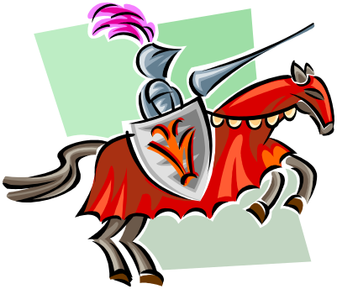
- The duty of the person shown above was to
  - Ride the horse in the local church parade
  - Hold the flag while the people recited the pledge of allegiance
  - Defend the manor against invaders
  - Teach the horse to stand on two feet.

- The strongest Germanic tribe to emerge during the 400s AD was the
  - Barbarians
  - Vikings
  - Franks
  - Germans

- Feudal society was characterized by
  - A hierarchical system of relationships and obligations
  - Increasing consolidation of power by Frankish kings
  - The absence of hostility between neighboring fiefs.
  - The rule of a strong central government

- The self-sufficiency of the manor was important because
  - Carpenters and blacksmiths could not leave the manor without permission
  - War and invasion made trade difficult
  - Heavy taxation made manufactured goods expensive
  - Few peasants were skilled as artisans

Eastern Hemisphere
- All of the following were routes of trade across the eastern hemisphere EXCEPT
  - Trans-Saharan
  - Silk Road
  - West coast of America
  - Across Russia connecting Northern Europe with the Black sea.

Use the map below to answer the questions that follow. Pay careful attention to map orientation.
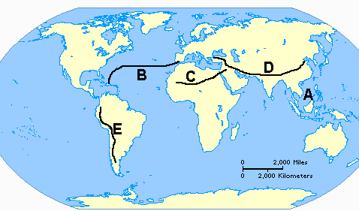
- On trade route would you cross the Sahara desert?
- On which trade route would you trade mainly with the countries of Southeast Asia?
- On which trade route would you probably trade gold?
- Which trade route is the Silk Road?
- On which trade route would Islam most likely be spread?

- Shintoism originated in
  - Rome
  - Arabia
  - China
  - Japan

- Printing and paper money originated in
  - Rome
  - Italy
  - China
  - Britain

- Timbuktu was the capital of which empire?
  - Ghana
  - Mali
  - Songhai
  - Zimbabwe

- Which of the following caused Islam to spread to North Africa?
  - Desire to spread Christianity in the New World
  - Development of plantations in the Spanish Empire in America.
  - Establishment of trans-Saharan commercial routes by Arab traders.
  - Restriction of Western trade in China’s ports by later Ming emperors.

- Which statement BEST describes the effects of the geography of Africa?
  - The geography of Africa has stimulated political and cultural unity.
  - The geography of Africa has resulted in most African countries having similar economic and social systems.
  - The geography of Africa has hindered economic development
  - Geography has encouraged physical mobility throughout Africa

Western Hemisphere

Use the map below to answer the questions that follow or to identify the places.
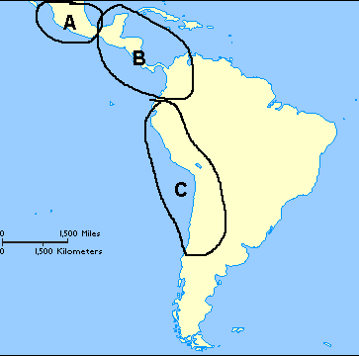
- Aztec
- Inca
- Maya
- Where are the Andes Mountains located?
- Where is the Yucatan Peninsula?

- Which empire was a warring empire?
  - Olmec
  - Mayan
  - Aztec
  - Incan

- What was the first civilization in Mesoamerica?
  - Olmec
  - Mayan
  - Aztec
  - Incan

- What was the Aztec capital?
  - Tenochtitlan
  - Cuzco
  - Yucatan
  - Toltec

Late Medieval Era
- Which leader united MOST of England
  - Hugh Capet
  - William the Conqueror
  - Philip II
  - King John

- King Henry is most known for
  - Uniting England
  - Common Law
  - Magna Carta
  - The Hundred Years War

- The Magna Carta
  - United England
  - Took power from the king
  - United France
  - Promoted the Church of England

- The Hundred Years War was between
  - England and Spain
  - Spain and France
  - England and France
  - Russia and Mongolia

- Which of the following is NOT an effect of the Crusades?
  - Weakened the monarchs
  - Stimulated trade in the Middle East
  - Made a legacy of bitterness among Christians, Muslims, and Jews.
  - Weakened the Byzantine Empire.

- What is Ivan the Great NOT known for?
  - Throwing off the rule of the Mongols.
  - Centralizing power in Moscow
  - Expanding the Russian nation
  - Promoting the Catholic Church

- The main attraction of town life for most people during the Middle Ages was that towns offered
  - The chance for economic advancement
  - Physical security
  - Educational and cultural advantages
  - A sense of continuity with the past.

Use the map below to answer the questions that follow.
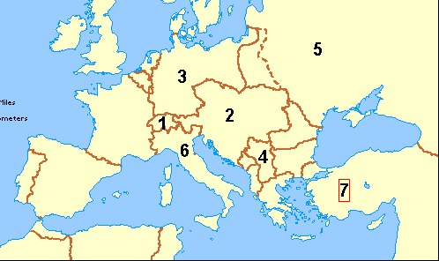
- In which area did common law, Parliament, and the jury system develop?
  - 3
  - 5
  - 9
  - 10

- In which area would you have found Moors?
  - 7
  - 8
  - 9
  - 10

- Where did William of Normandy go in 1066?
  - 3
  - 6
  - 8
  - 10

- Where did Urban tell the people to go?
  - 2
  - 6
  - 7
  - 9

- Where would you have found Ferdinand’s kingdom?
  - 3
  - 5
  - 7
  - 9

- Where would you find Jean d’Arc?
  - 1
  - 3
  - 8
  - 10

- During the Reconquista, Christian Spaniards drove out the
  - Turks
  - French
  - Mongols
  - Moors

- Which of the following did NOT stimulate the development of the French and English nations?
  - The Norman Conquest of 1066
  - The fighting of the Hundred Years War
  - The Muslim invasions
  - The legendary heroism of Joan of Arc

- The appearance of the Black Death is an important event in Western history because
  - It weakened European nations and opened the way for the Mongol conquest
  - It restricted the movement of many people for fear of spreading the disease
  - A manpower shortage led to the development of a money economy
  - It strengthened the morale and authority of the Catholic clergy.

- One of the first contracts between people and government was signed in1215. What is the specific circumstance?
  - The nobles are making King John give up some powers in England.
  - The Moors are being forced to give up land in France.
  - Joan is being released from captivity by royal decree.
  - Ivan is forcing the Mongols into a peace treaty.

Foundations of the Renaissance
- The time known as the Renaissance was important because it
  - Was a distraction from the horrors of the Black Death and the Hundred Years’ War.
  - Reinforced the authority of the teachings of the Catholic Church.
  - Represented a revival of interest in literature, science, and the arts.
  - Resisted the trend toward increasing trade and wealth.

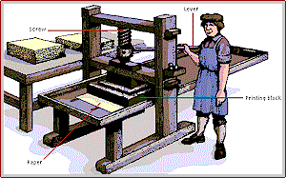
- The most important work this device did during the Renaissance was
  - Destroy feudalism
  - Help defeat the Muslims
  - Made traveling easier
  - Help educate the masses and spread new ideas

- So people did not have to carry a lot of money around, banks started
  - Patrons
  - Letters of credit
  - Usury
  - Interest

- What does NOT go with Humanism?
  - Celebrated the individual
  - Stimulated the study of Greek and Roman literature and culture
  - Religious icons were the most important
  - Was supported by wealthy patrons.

- The economic foundation of the Renaissance is
  - The patronage of wealthy merchants and bankers
  - French political influence in Italy
  - The spoils of military conquests.
  - The power the of modern nation-state.

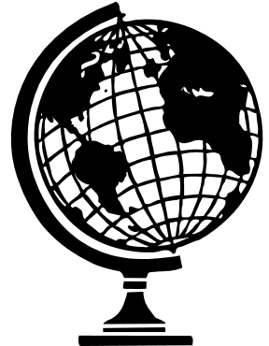

- The biggest problem with the device above is
  - Distortion
  - Too big
  - Scale
  - Detail

True or False Section
Fill bubble “A” for true and “B” for false.

- Homo sapiens emerged in Africa between 100,000 to 400,000 years ago.
- Ancient Egyptian writing is called Cuneiform.
- Classical China contributed paper, porcelain, silk, and the civil service system to our modern world.
- Greek mythology is a polytheistic religion.
- Carthage won the first two Punic Wars.
- Theodosius was the greatest Byzantine emperor.
- The Sunni/Shi’a division in Islam results from a difference in beliefs over who Mohammed’s descendants are.
- The tribe of Franks emerged as a political force in Western Europe after the fall of the Greek Empire.
- The ethnic religion of Japan is Shinto.
- William the Conqueror united England in 1066.
- Humanism celebrated the accomplishments of the great civilizations of the Western Hemisphere.

